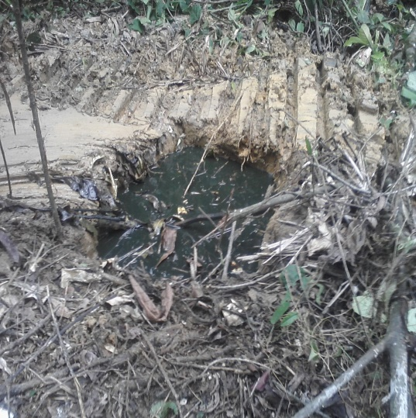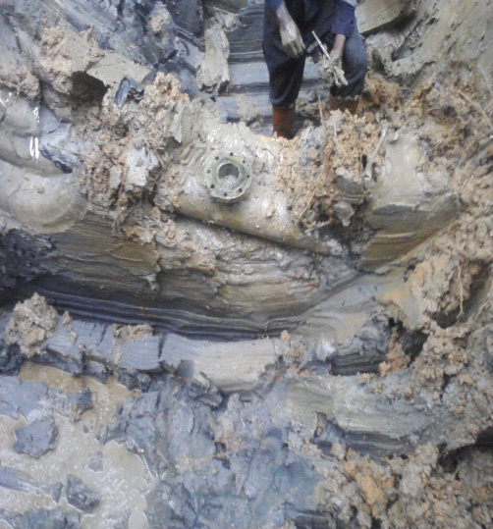
FIGURE 1- OVERVIEW PICTURE OF THE SITE FIGURE 2- THE ILLEGAL VALVE
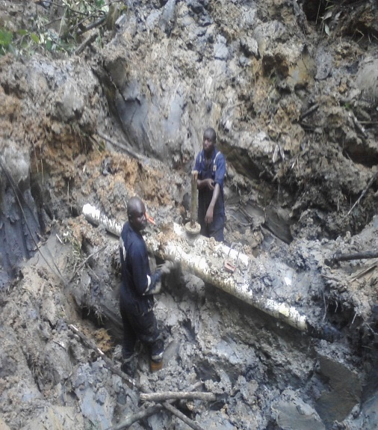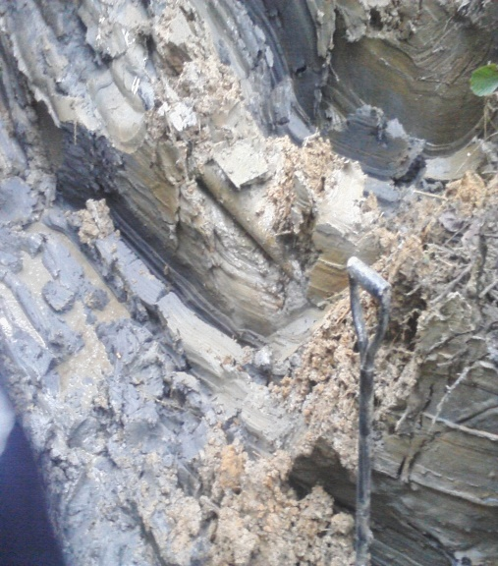
FIGURE 3- THE PEGGING PROCESS FIGURE 4-THE BLIND FOLDING PROCESS
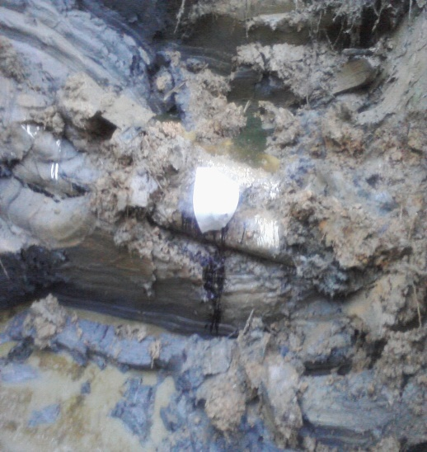
FIGURE 5 THE WRAPPED STAGE

